Case Study 1: Design Minimum 10 Project and Product Items
Objective: Identify at least ten software projects and ten software products that can be used as reference applications for the test case design exercises in this record.

Projects
- College Management System
- Employee Payroll Management System
- Online Banking System
- Hospital Management System
- Library Management System
- Finance Management System
- Airline Booking System
- Student Attendance Management System
- Online Ticket Booking System
- Hostel Management System
- E-Commerce Website
- Employee Training Program
- College Fest Organization Portal
- Carpooling Web Application
- Vehicle Rental Management System
- Hotel Booking System
- Digital Library Development
- College Placement Management System

Products
- Naukri.com
- Amazon
- Flipkart
- Google Maps
- Swiggy
- Uber
- Netflix
- Spotify
- LinkedIn
- Zomato
- Apple Music
- Microsoft Word
- Instagram
- Facebook
- PhonePe
- Paytm
- Microsoft Teams

Case Study 2: Equivalence Class Partitioning (ECP)
Equivalence Class Partitioning is a black-box test case design technique in which the input data of a software unit is divided into partitions (classes) of equivalent data from which test cases can be derived. Instead of testing every possible input, one representative value is chosen from each valid and invalid class, which reduces the number of test cases while still covering the input domain effectively.

Example 1: Valid Range of Integer Input
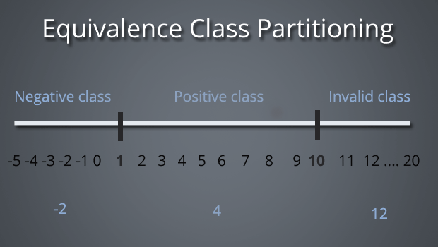
S. No | Normal Test Data | Divide Values into Equivalence Class | Test Data Using ECP
1 | -2 | Negative Class – Values from -5 to 0 | -2
2 | 4 | Positive Class – Values from 1 to 10 | 4
3 | 12 | Invalid Class – Values from 11 to 20 | 12

Example 2: Age Validation (18–60 Eligibility)
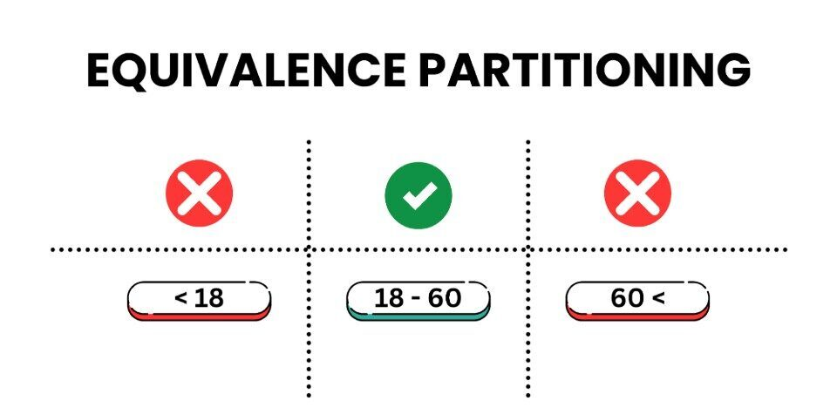
S. No | Normal Test Data | Divide Values into Equivalence Class | Test Data Using ECP
1 | 15 | Invalid Class – Age less than 18 | 15
2 | 35 | Valid Class – Age from 18 to 60 | 35
3 | 65 | Invalid Class – Age greater than 60 | 65

Example 3: Marks / Score Validation (Grading)
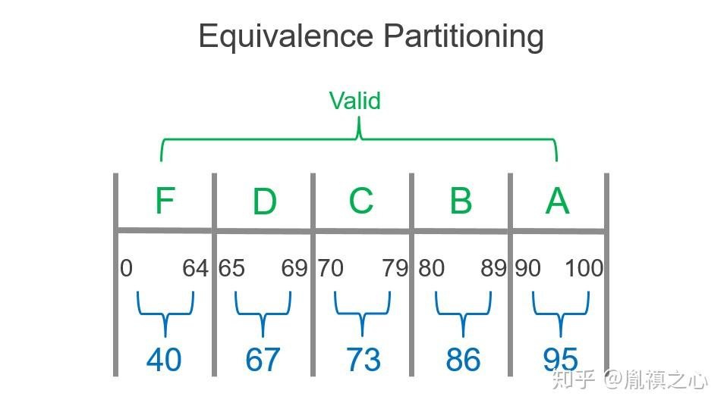
S. No | Normal Test Data | Divide Values into Equivalence Class | Test Data Using ECP
1 | 40 | Valid Class – F Grade: 0–64 | 40
2 | 67 | Valid Class – D Grade: 65–69 | 67
3 | 73 | Valid Class – C Grade: 70–79 | 73
4 | 86 | Valid Class – B Grade: 80–89 | 86
5 | 95 | Valid Class – A Grade: 90–100 | 95

Example 4: Password Length Validation
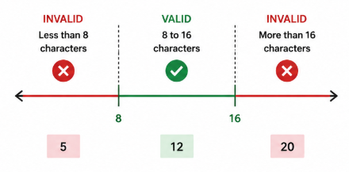
S. No | Normal Test Data | Divide Values into Equivalence Class | Test Data Using ECP
1 | 5 characters | Invalid Class – Less than 8 characters | 5
2 | 12 characters | Valid Class – 8 to 16 characters | 12
3 | 20 characters | Invalid Class – More than 16 characters | 20

Example 5: PIN Code Validation
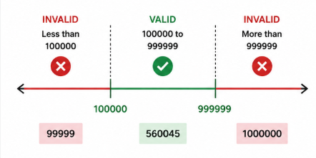
S. No | Normal Test Data | Divide Values into Equivalence Class | Test Data Using ECP
1 | 99999 | Invalid Class – Less than 100000 | 99999
2 | 560045 | Valid Class – 100000 to 999999 | 560045
3 | 1000000 | Invalid Class – More than 999999 | 1000000

Example 6: Application Number Field (1–500 Digits) – Income Tax Slab
Design an equivalence class partition for an application number field that accepts values from 1 to 500, illustrated below using an income-tax slab as a reference scale.
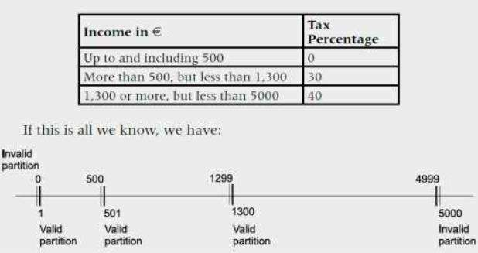
S. No | Normal Test Data | Divide Values into Equivalence Class | Test Data Using ECP
1 | 0 | 0 → Invalid | 0
2 | 250 | 1 – 500 → Valid | 250
3 | 900 | 501 – 1299 → Valid | 900
4 | 3000 | 1300 – 4999 → Valid | 3000
5 | 5500 | 5000 and above → Invalid | 5000

Example 7: Next-Date Validation (Day / Month / Year)
A next-date function accepts a Day, Month and Year, and returns the incremented date, the reset date and month, or an invalid-date result. The equivalence classes below cover the valid and invalid day/month/year combinations.
Test Case | Day | Month | Year | Expected Output
1 | D1 | M1 | Y1 | Increment day
2 | D1 | M1 | Y2 | Increment day
3 | D1 | M2 | Y1 | Increment day
4 | D1 | M2 | Y2 | Increment day
5 | D1 | M3 | Y1 | Increment day
6 | D1 | M3 | Y2 | Increment day
7 | D2 | M1 | Y1 | Increment day
8 | D2 | M1 | Y2 | Increment day
9 | D2 | M2 | Y1 | Increment day
10 | D2 | M2 | Y2 | Increment day
11 | D2 | M3 | Y1 | Reset day and increment month
12 | D2 | M3 | Y2 | Invalid date
13 | D3 | M1 | Y1 | Reset day and increment month
14 | D3 | M1 | Y2 | Reset day and increment month
15 | D3 | M2 | Y1 | Increment day
16 | D3 | M2 | Y2 | Increment day
17 | D3 | M3 | Y1 | Invalid date
18 | D3 | M3 | Y2 | Invalid date
19 | D4 | M1 | Y1 | Invalid date
20 | D4 | M1 | Y2 | Invalid date
21 | D4 | M2 | Y1 | Reset day and increment month
22 | D4 | M2 | Y2 | Reset day and increment month
23 | D4 | M3 | Y1 | Invalid date
24 | D4 | M3 | Y2 | Invalid date

Example 8: Purchase Amount – Discount Slab
S. No | Normal Test Data | Divide Values into Equivalence Class | Test Data Using ECP
1 | 500 | Below 999 → Invalid | 500
2 | 1500 | 999 – 1998 → Valid (5% discount) | 1500
3 | 2500 | 1999 – 3998 → Valid (10% discount) | 2500
4 | 4500 | 3999 – 5998 → Valid (15% discount) | 4500
5 | 6500 | 5999 – 7998 → Valid (25% discount) | 6500
6 | 8500 | 7999 – 9998 → Valid (35% discount) | 8500
7 | 10500 | 9999 and above → Valid (50% discount) | 10500

Example 9: Mobile Number Validation (Must Be 10 Digits)
S. No | Normal Test Data | Divide Values into Equivalence Class | Test Data Using ECP
1 | 987654321 | Less than 10 digits → Invalid | 987654321
2 | 9876543210 | Exactly 10 digits → Valid | 9876543210
3 | 98765432109 | More than 10 digits → Invalid | 98765432109

Example 10: Age Field Validation (18–56 Eligibility)
S. No | Normal Test Data | Divide Values into Equivalence Class | Test Data Using ECP
1 | 17 | Age ≤ 17 → Invalid | 17
2 | 30 | Age 18 – 56 → Valid | 30
3 | 57 | Age ≥ 57 → Invalid | 57

Case Study 3: Decision Table Technique
Objective: Search five real-world scenarios that can be modelled as decision tables, identify the conditions, and derive the corresponding actions.

Example 1: User Registration and Password Validation
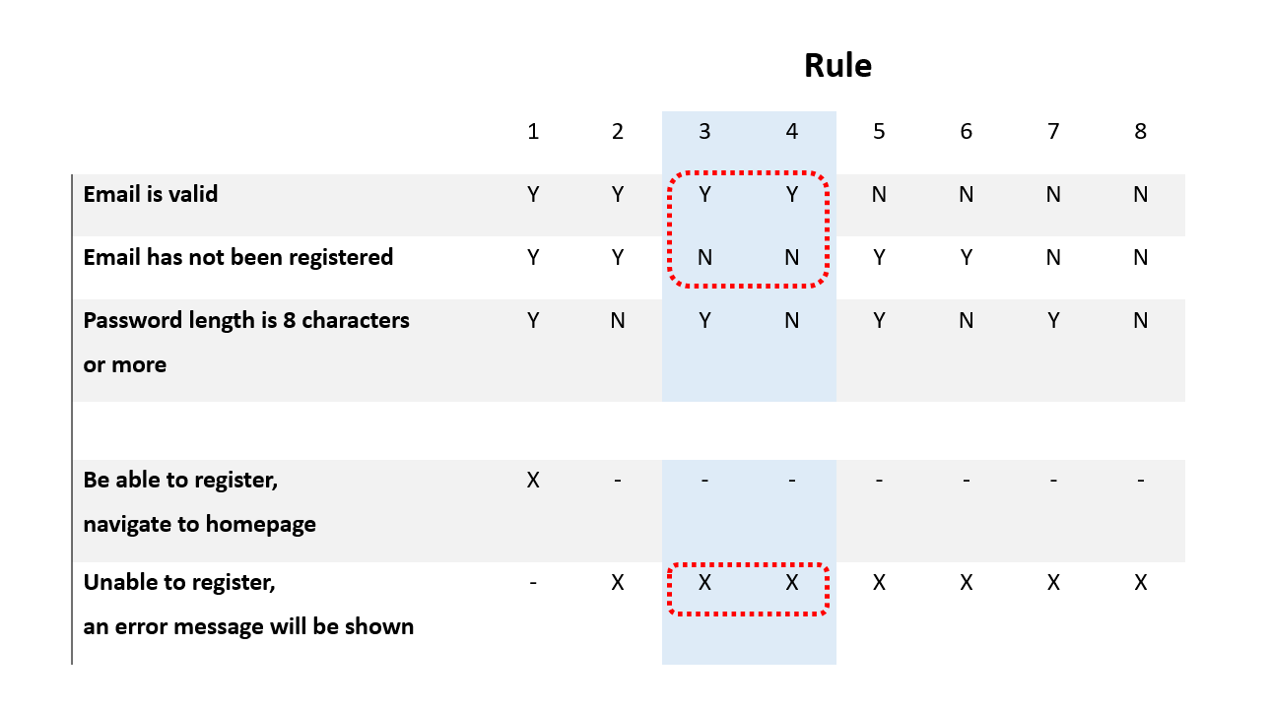

Conditions
- Email is valid
- Email has not been registered already
- Password length is 8 characters or more

Actions
- User is able to register and is navigated to the homepage
- User is unable to register and an error message is displayed

Example 2: Printer Troubleshooting
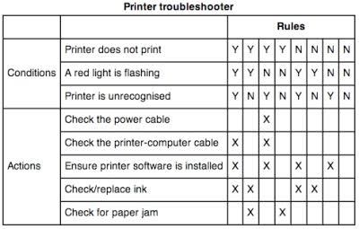

Conditions
- Printer does not print
- A red light is flashing
- Printer is unrecognized by the system

Actions
- Check the power cable
- Check the printer–computer cable
- Ensure the printer software/driver is installed
- Check or replace the ink cartridge
- Check for a paper jam

Example 3: Customer Discount and Bonus Coupon
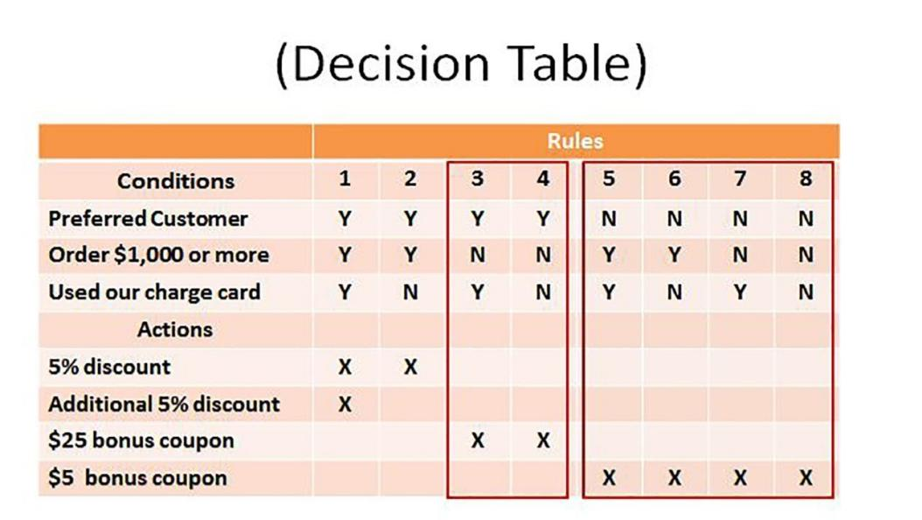

Conditions
- Preferred customer
- Order value is $1,000 or more
- Customer used the store charge card

Actions
- 5% discount
- Additional 5% discount
- $25 bonus coupon
- $5 bonus coupon

Example 4: Bank Withdrawal Validation
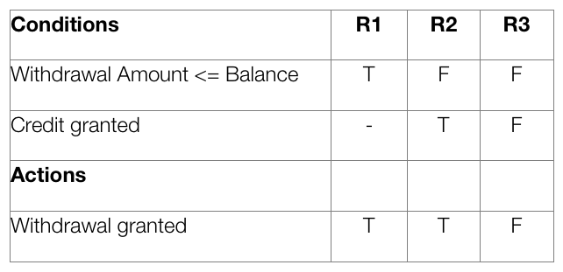

Conditions
- Withdrawal amount ≤ account balance
- Credit/overdraft has been granted

Actions
- Withdrawal is granted
- Withdrawal is denied

Example 5: Flight Discount Eligibility
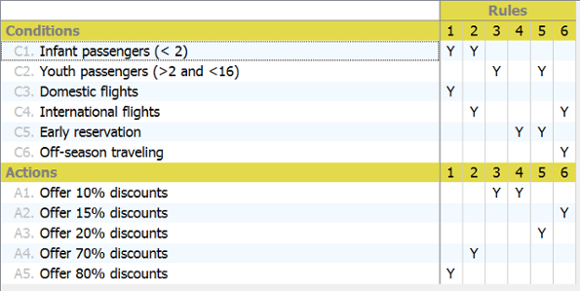

Conditions
- Infant passenger (under 2 years)
- Youth passenger (over 2 and under 16 years)
- Domestic flight
- International flight
- Early reservation
- Off-season travel

Actions
- Offer 10% discount
- Offer 15% discount
- Offer 20% discount
- Offer 70% discount
- Offer 80% discount

Case Study 4: State Transition Technique
Objective: Identify at least five real-world screens/workflows and model their behaviour as state transition diagrams, listing the valid, invalid and final transitions.

Example 1: ATM PIN Authentication
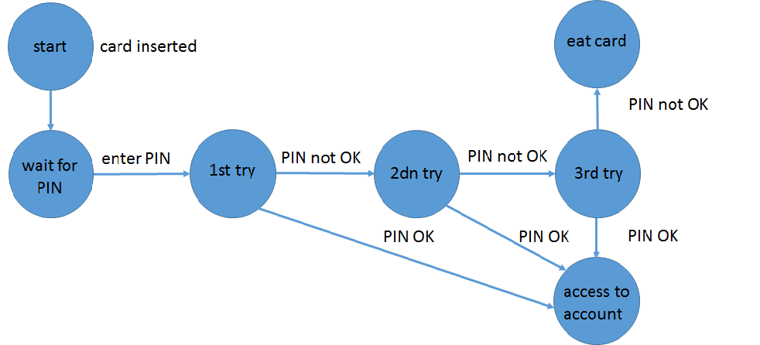

States
Start → Wait for PIN → 1st Try → 2nd Try → 3rd Try → Access to Account / Card Retained

Valid Transitions
- Correct PIN at 1st attempt → Access to Account
- Correct PIN at 2nd attempt → Access to Account
- Correct PIN at 3rd attempt → Access to Account

Invalid Transitions
- Incorrect PIN at 1st attempt → 2nd Try
- Incorrect PIN at 2nd attempt → 3rd Try
- Incorrect PIN at 3rd attempt → Card Retained

Final Transitions
- Correct PIN → Access to Account
- Three consecutive incorrect PIN attempts → Card Retained

Example 2: Login Attempt Validation
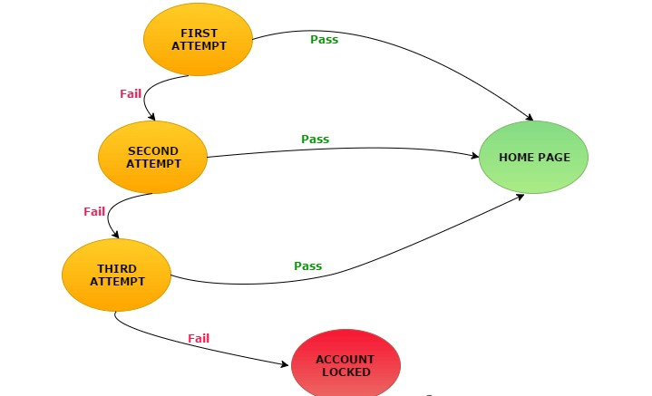

States
First Attempt → Second Attempt → Third Attempt → Home Page / Account Locked

Valid Transitions
- Correct credentials at First Attempt → Home Page
- Correct credentials at Second Attempt → Home Page
- Correct credentials at Third Attempt → Home Page

Invalid Transitions
- Incorrect credentials at First Attempt → Second Attempt
- Incorrect credentials at Second Attempt → Third Attempt
- Incorrect credentials at Third Attempt → Account Locked

Final Transitions
- Correct credentials → Home Page
- Three consecutive failed attempts → Account Locked

Example 3: Airline Selection and Boarding Pass Printing
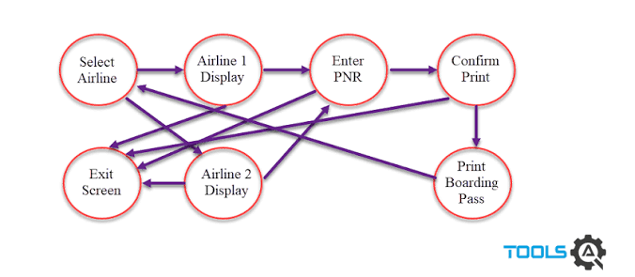

States
Select Airline → Airline 1 Display / Airline 2 Display → Enter PNR → Confirm Print → Print Boarding Pass / Exit Screen

Valid Transitions
- Select Airline → Airline 1 Display
- Select Airline → Airline 2 Display
- Airline Display → Enter PNR
- Enter PNR → Confirm Print
- Confirm Print → Print Boarding Pass

Invalid Transitions
- Invalid airline selection → Exit Screen
- Invalid PNR → Exit Screen
- Unable to confirm print → Exit Screen

Final Transitions
- Confirm Print → Print Boarding Pass
- Exit Screen → End of Process

Example 4: MDF (Marketing Development Fund) Program Status
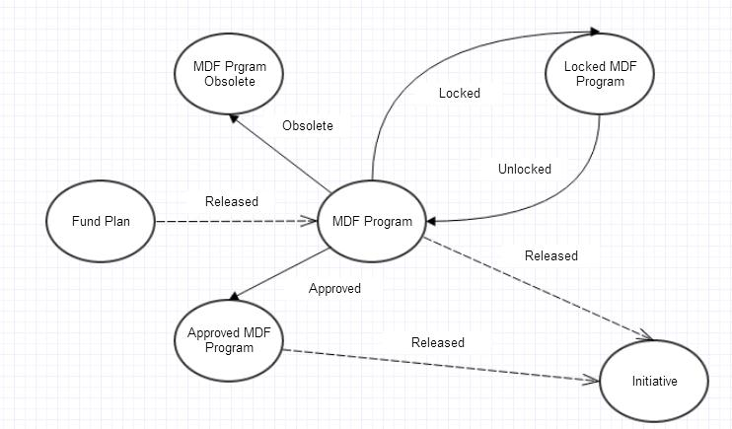

States
Fund Plan → MDF Program → Approved MDF Program / Locked MDF Program / MDF Program Obsolete → Initiative

Valid Transitions
- Fund Plan → MDF Program (Released)
- MDF Program → Approved MDF Program (Approved)
- MDF Program → Locked MDF Program (Locked)
- Locked MDF Program → MDF Program (Unlocked)
- Approved MDF Program → Initiative (Released)
- MDF Program → Initiative (Released)

Invalid Transitions
- MDF Program → Approved MDF Program without approval
- MDF Program → Locked MDF Program without meeting the lock condition
- Locked MDF Program → MDF Program without unlocking

Final Transitions
- MDF Program → MDF Program Obsolete (Obsolete)
- Approved MDF Program → Initiative (Released)
- MDF Program → Initiative (Released)

Example 5: Library Book Rental System
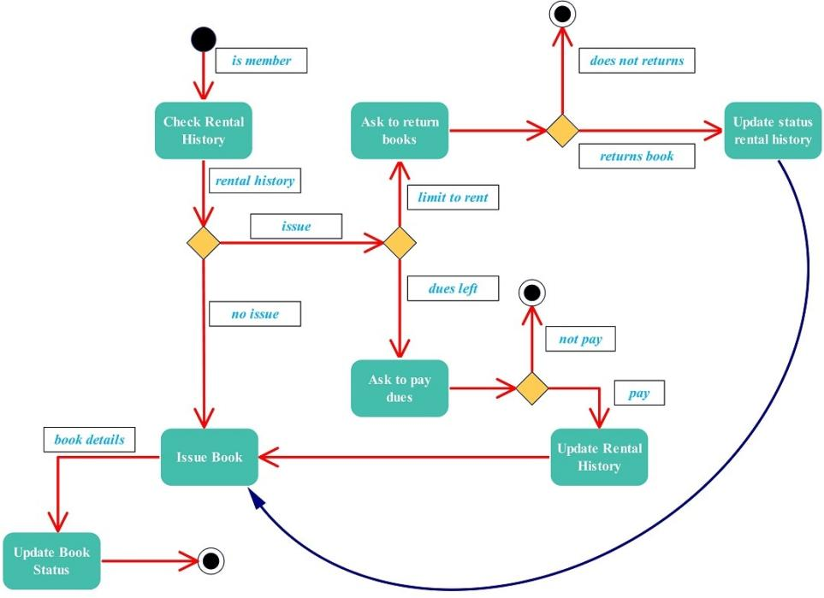

States
Check Rental History → Issue Book → Ask to Return Books → Update Rental History → Update Book Status

Valid Transitions
- Member has no outstanding issue in rental history → Issue Book
- Member pays the outstanding dues → Issue Book
- Member reaches the rental limit → Ask to Return Books
- Member returns the book → Update Rental History → Issue Book
- Book is issued → Update Book Status → Process completed

Invalid Transitions
- Member has an outstanding issue/due → cannot directly issue the book → Ask to Pay Dues
- Member does not pay the dues → Process terminates
- Member does not return the book when requested → Process terminates

Case Study 5: Boundary Value Analysis (BVA)
Boundary Value Analysis focuses testing on the edges of each equivalence class, since defects are statistically more likely to occur at the boundaries of the valid input range than in the middle of it.

Equivalence Class Partitioning – Reference Table
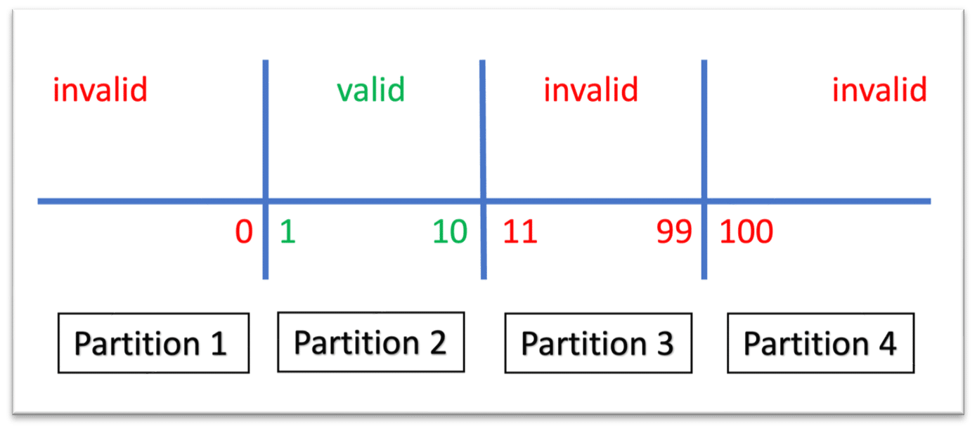
S. No | Normal Test Data | Divide Values into Equivalence Classes | Test Data Using ECP
1 | 0 | EC1 – Invalid: Value ≤ 0 | 0
2 | 1 | EC2 – Valid: 1 ≤ Value ≤ 10 | 5
3 | 11 | EC3 – Invalid: 11 ≤ Value ≤ 99 | 50
4 | 100 | EC4 – Invalid: Value ≥ 100 | 100

Boundary Value Test Cases
S. No | Condition | Status
1 | BVA Min
 | Min − 1 = 0 | Failed
 | Min = 1 | Passed
 | Min + 1 = 2 | Passed
2 | BVA Max
 | Max − 1 = 9 | Passed
 | Max = 10 | Passed
 | Max + 1 = 11 | Failed

